**Blockchain Foundry Inc.**

**What Is It?**

Provide custom blockchain consulting, development and integration solutions that help leverage blockchain technologies to solve business problems. Use blockchains to replace company softwares making the company data decentralized saving manutence costs since do not use servers and do not need regular backups.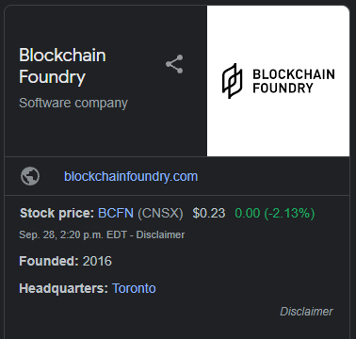

Blockchain Foundry’s mission is to disrupt markets by leveraging the potential of blockchain technology.

**Why This Matters?**

The blockchain technology helps to avoid mistakes since the nodes need to aprovel the new block and security breaches. This type of technology is especially critical in markets where a one-minute supply chain inefficiency can lead to massive revenue increases.

According to the Blockchain Foundry website they believe blockchains will fundamentally change how organizations think about doing business, and they are committed to unlocking the blockchain’s potential, not being focused on a specific blockchain protocol.

**Why This May be Interesting?**

Blockchain Foundry helps any type of business get inside the blockchain technology and not just financial companies or cryptocurrencies, helping day-to-day operations that need fast access to information and may have data sensitive.

Some examples of business that could use the blockchain are:

-Hospitals

-Security Firms

-Law Firms

-Marketing Research Companies

-Logistic Companies….

**Resources**

Blockchain Foundry Website<https://blockchainfoundry.com/>

Yahoo Finance <https://ca.finance.yahoo.com/quote/BCFN.CN/>

Crunchbase <https://www.crunchbase.com/organization/blockchain-foundry>